95712C Lecture Notes

Wednesday, September 29, 2004

StringTokenizer Class
Reference: Chapter 12 of Core Java
The StringTokenizer class helps to break the sentences into individual words, which are called tokens. The tokens are separated by delimeters, usually the white space characters. The StringTokenizer class is defined in the java.util package.
- public StringTokenizer(String str)
- public StringTokenizer(String str, String delim)
Constructs a string tokenizer for the specified string. The characters in the delim argument are the delimiters for separating tokens.
- public StringTokenizer(String str, String delim, boolean returnTokens)
If the returnTokens flag is true, then the delimiter characters are also returned as tokens.
- boolean hasMoreTokens() returns true if more tokens exist.
- String nextToken() returns the next token.
See the example in the next section.

Introduction to Files and Input/Output
Reference: Chapter 12 of Core Java.
We will study the files and Java I/O later. Let us see briefly how to read from and write to I/O streams.
See the example below for reading from a file through buffered stream.
import java.io.*;
import java.util.StringTokenizer;
public class Demonstrate {
public static void main(String argv[]) throws IOException {

BufferedReader instream = new BufferedReader( new FileReader("input.data"));
PrintWriter outstream = new PrintWriter( new FileWriter("output.data"));

String line;
while ( (line = instream.readLine()) != null) {
StringTokenizer tokenizer = new StringTokenizer(line);
int sum = 0;
while (tokenizer.hasMoreTokens()) {
sum += Integer.parseInt(tokenizer.nextToken());
}
outstream.println("The sum is: " + sum);
}

instream.close();
outstream.close();
}
}
While reading or writing the File streams, an exception may occur such as input file not found or permission denied writing on output file. In such situations, Java throws an I/O exception such as FileNotFoundException . For the time being, we will not deal with the exception: We will simply declare that a method can throw a particular exception and we will not write any code to catch that exception.
Three stream objects created automatically: System.in which is the stream that flows from the keyboard to the program, System.out which is the stream that flows from program to display unit, and System.err that enables the program to output error messages to the display unit.
Keyboard -> System.in -> Program -> System.out -> Display
To read from the keyboard, System.in.read reads a single character from the standard input. To read the input as tokens, create an InputStreamReader object.

import java.io.*;
import java.util.StringTokenizer;
public class Demonstrate {
public static void main(String argv[]) throws IOException {
BufferedReader in = new BufferedReader( new InputStreamReader(System.in));
String line;
while ( (line = in.readLine()) != null) {
StringTokenizer tokenizer = new StringTokenizer(line);
while (tokenizer.hasMoreTokens()) {
System.out.println(tokenizer.nextToken());
}
}
}
}

See DataFileTest.java

Inheritance and Polymorphism, Continued
Reference: Chapter 5 of Core Java, Chapter 6 of Thinking In Java.

Pure Inheritance vs Extension (Substitution Principle)
In pure inheritance, the base class establishes the interface for the whole inheritance hierarchy. Subclasses override the implementation without adding new methods.
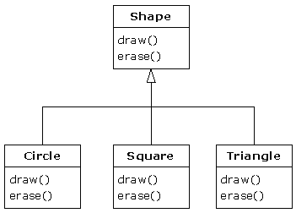
This can be thought of as pure substitution, because derived class objects can be perfectly substituted for the base class, and you never need to know any extra information about the subclasses when you’re using them:
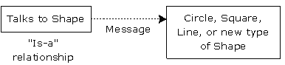
A new type of shape can be introduced into the inheritance hierarchy without changing the code in the “Talks to Shape” box. Everything is handled through polymorphism.
On the other hand, often the sub classes have other features that require additional methods to implement:
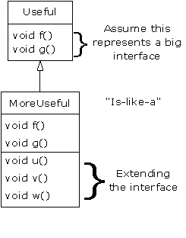
While this is also a useful and sensible approach (depending on the situation), it has a drawback. The extended part of the interface in the derived class is not available from the base class, so you can’t call the new methods:
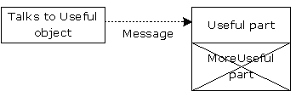
You’ll get into a situation in which you need to rediscover the exact type of the object so you can access the extended methods of that type, which is studied next.

Casting
- An object reference of type super class can refer to any object of sub classes. The reverse is not true, you need an explicit cast in order to compile.
- You can cast within an inheritance hierarchy. Try to minimize the casting as possible.
- Use instanceof operator before casting a super class object to a sub class one.

class Employee {
}
class Manager extends Employee {
}
class Engineer extends Employee {
}
public class CastingDemonstrate {
public static void main(String argv[]) {
Employee e = new Employee();
Manager m = new Manager();
Engineer en = new Engineer();

e = m; // OK
//m = e; // compile error

e = new Manager();
// m = e; // again, compile error.
m = (Manager)e;

e = new Engineer();
// m = (Manager)e; // run time cast exception.

if (e instanceof Manager) {
m = (Manager)e;
}
}
}

Order of Constructor Calls
See the Sandwich.java as an example of how the default constructors are invoked. When writing non-default constructors, make sure to call the super constructor in order to achieve the correct sequence of constructor calls.

Benefits of Polymorphism
- Generic Programming: Polymorphism enables you to use just one type and any subclass is taken care of.
- Dynamic Binding: Correct implementation (right behavior) is obtained via the actual type.
- Extensibility: A new class can be added into the hierarchy without changing the generic code.

Abstract Classes
An abstract class has no instances. No instance of an abstract class can be created as they are considered too generic. However, we can have references to abstract classes.
An abstract class may contain abstract methods, that is, methods with no implementation. In this case, the subclasses must implement the abstract methods. In this respect, abstract classes establish an interface.
Abstract classes usually hold instance variables and setter and getter methods for the instance variables.
An example abstract class is the Number class in the java.lang package represents the abstract concept of numbers. It makes sense to model numbers in a program, but it doesn't make sense to create a generic number object. Instead, the Number class makes sense only as a super class to classes like Integer and Float, both of which implement specific kinds of numbers.
abstract class Number {
. . .
}

See PersonTest.java

The following example creates a hierarchy for a payroll system (adapted from Deitels – Java How To Program). See AbstractEmployee.java

The Object Class
See EqualsTest.java regarding the equals, toString and getClass methods.

Overriding private methods ?
Private methods are final. If you define a method in a subclass with the same signature of a private method in super class, you are actually defining a new method in the sub class.
Don’t.

class E {
private void f() {
System.out.println("E");
}
public void g() {
f();
}
}

public class D extends E {

private void f() {
System.out.println("D");
}
public void g() {
f();
}
public static void main(String[] args) {
E e = new E();
e.g();

D d = new D();
d.g();
}
}

What if class D doesn’t define g() at all?

Overloading an inherited method
It is possible but don’t.

class E {
private void f() {
System.out.println("E");
}
public void g() {
f();
}
}

public class D extends E {

private void f() {
System.out.println("D");
}
public void g() {
f();
}
public void g(int i) {
f();
}
public static void main(String[] args) {
E e = new E();

D d = new D();
d.g();
d.g(1);
}
}

What if class D doesn’t define g() at all?

Behavior of polymorphic methods inside constructors
class E {
private void f() {
System.out.println("E");
}
E() {
g();
}
public void g() {
f();
}
}

public class D extends E {

private void f() {
System.out.println("D " + i);
}
public void g() {
f();
}
D() {
i = 10;
g();
}
private int i;
public static void main(String[] args) {

D d = new D();
}
}
This is different from C++. Inside Java constructors, eliminate calls to methods that can be overridden.

ArrayList revisited
See ArrayListTest.java

Reflection
See ReflectionTest.java
See ObjectAnalyzerTest.java
See ArrayGrowTest.java

